COIT20246 Cyber Security and Networking Project Report

1. Introduction
This project aims to design, configure and secure a small business network using technologies OpenWRT and Virtual Box. The case scenario selected is a small firm that offers the business accounting and tax services to clients in Brisbane, Australia. Accounting firms have access to sensitive data including customer financial data, payroll information, tax documents, and employee details, and effective cybersecurity is essential for confidentiality, integrity and reliability of data.

2. Assumptions

To create a realistic network design and cybersecurity implementation for the business scenario that was selected, several assumptions were made for this project. These assumptions are used throughout the process of configuring the network environment, security controls, and risk assessment activities.
The company is presumed to be Brisbane Tax & Accounting Services Ltd, a small accounting and financial consultancy company in Brisbane, Australia. It's a business that offers a range of services such as tax preparation, payroll, bookkeeping, financial reporting, and general business consultation for its local clients. This type of business was chosen as it deals with highly confidential financial information and Cyber Security is one of the very important requirements.

3. Network Setup

For this project, a network environment has been designed by installing OpenWRT in Virtual Box to provide a small business network infrastructure. OpenWRT is the main router / firewall routing the communication between internal devices and external networks. Implements a secure networking setup using low cost, open-source technologies, and to demonstrate a way in which a small organisation can implement such practices.
The OpenWRT virtual machine has two network adapters configured. The first adapter was connected to NAT (Network Address Translation) mode where OpenWRT could use the host to connect to the internet. While enhancing the security of internal networks and making internet access easy for virtual machines, NAT hides the internal network addresses for outgoing Internet connectivity.
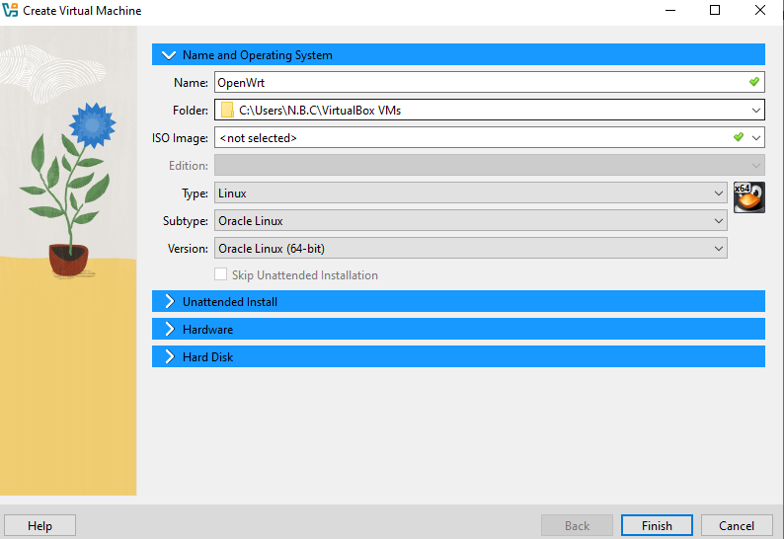
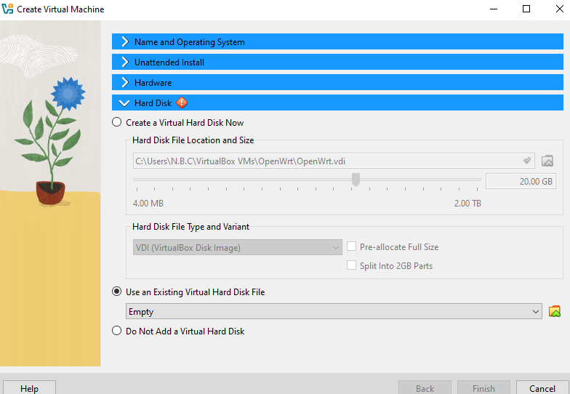
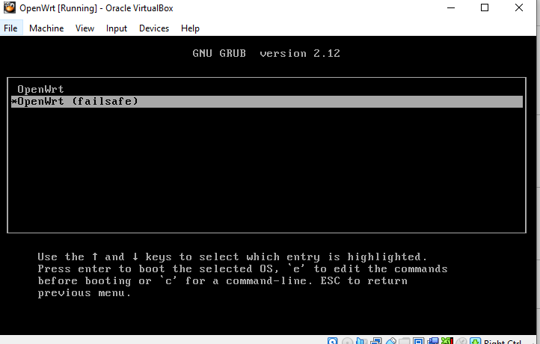
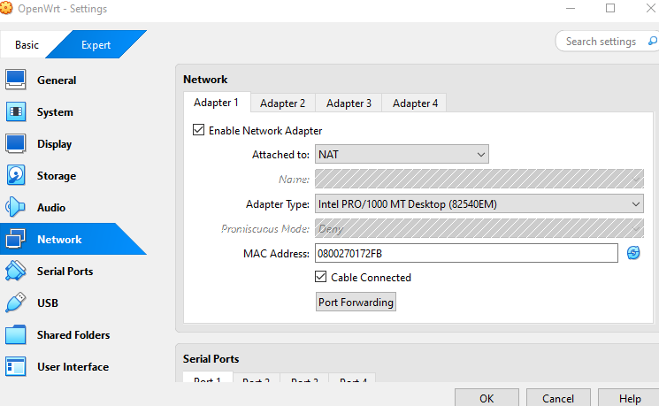
Host only I used the second adapter, which is used for communication in the virtual domain between the Windows host computer and the OpenWRT virtual machine, but does not expose the traffic under the virtual machine on the network directly.

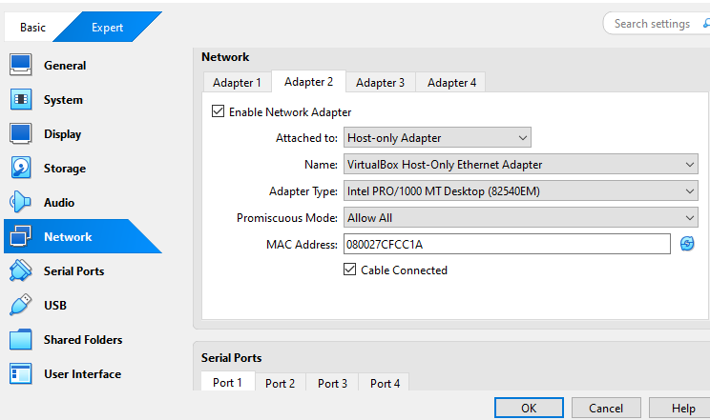
This setup provides management access, testing and packet analysis in the controlled environment.
OpenWRT interfaces were set up to enable routing between these adapters. The external interface (WAN) is used to link to the NAT network, and the internal interface (LAN) is used to link devices in the simulated business network. Local Web Server was installed on OpenWRT and used to simulate the business website and the loopiness between network devices.
All operations were carried out from the Windows host system, such as accessing website hosted, executing ping tests, SSH sessions and analyzing the traffic with Wireshark. Through the connectivity test, it was found that there is communication between the host machine and the OpenWRT environment.
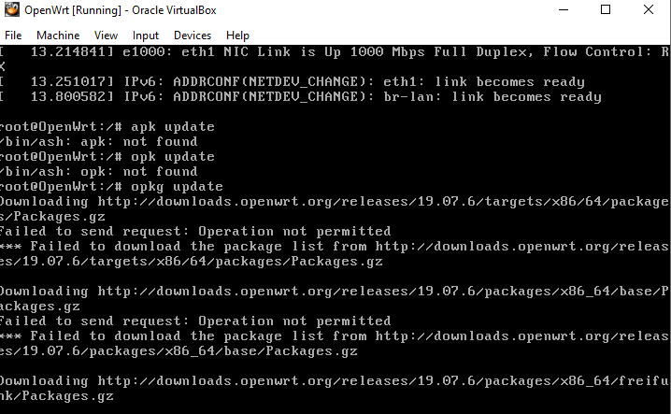
We should use a network diagram to show how the Windows host, OpenWRT router, NAT adapter and internal network interfaces are related. Further, an IP allocation table should include information about the IP address to which each router, server and workstation are assigned. The diagrams and tables are useful for understanding the structure of networks, and to troubleshoot, configure and plan security.
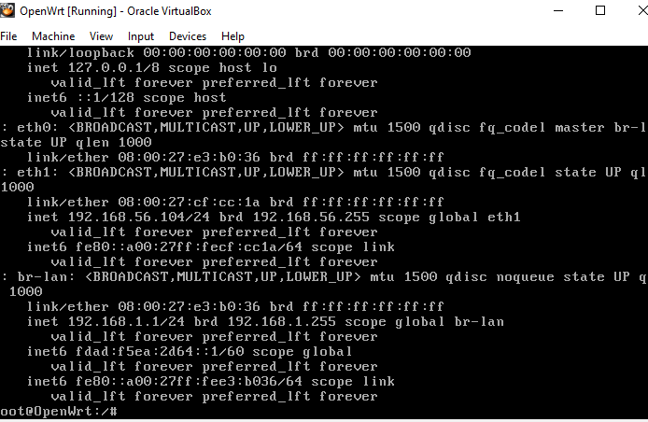

4. Firewall Rules
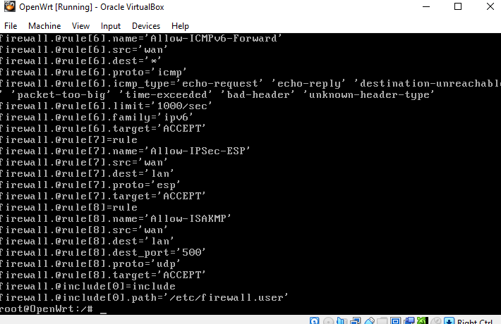
After careful study, a custom firewall configuration has been setup, to get even better network security effects by limiting traffic coming in and going out of the network. Addressing issues with access to internal systems, exposure to attacks and limiting potentially harmful communication with these rules.
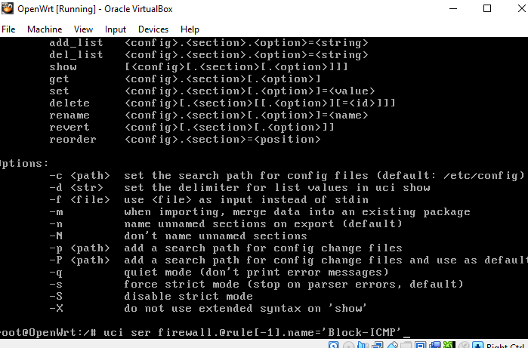

The first firewall configuration reduced access to the hosted Web server to the local area network (LAN) (port 80 was denied). The web site was originally only accessible from the Windows host system. Following the firewall rule applied, the user was not able to access the website, thus indicating that access to the website was successfully blocked due to the HTTP traffic. The rule was subsequently removed to re-enable access to the website and to check that they were behaving correctly.
The second one was dedicated to the SSH security part. SSH was first allowed to connect on port 22 (the default port). To avoid use of the standard port for automated attacks and port scanning, SSH was re-routed to a non-standard port (2222). Once tested, a connection across the port 22 was unsuccessful while one across the port 2222 was succeed.
The third rule was block icmp traffic (block ping request between the device). Ping tests worked at the start but did not work after turning on the restriction for firewall.
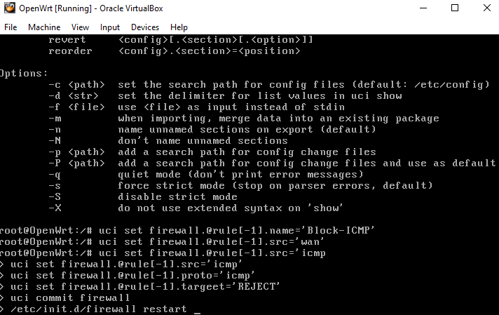
ICMP-access was re-enabled, to regain normal communication. The last but not least, access to OpenWRT was cut off from unauthorized admin access via the management interface. Blocking the management port diminishes attacker’s ability to make changes to the configuration. The firewall rules listed here serve as examples of putting security into practice by minimizing vulnerabilities in the network.
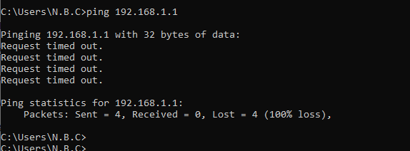
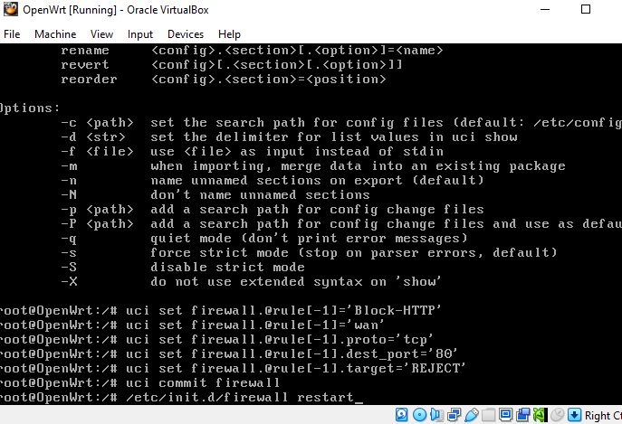
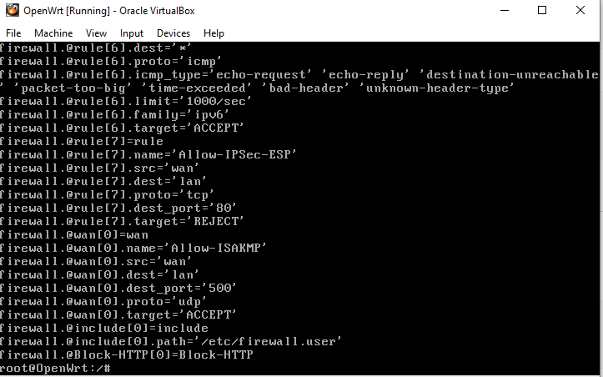

5. Production Network Design
A production network design was created through the selected small business environment considering how this production system would function in a real production environment. The hosting plan for the network encompasses such as an OpenWRT router/firewall, network switch, a number of workstations for employees, a web server, and Network printer linked to an internal business network. The router is between the organisation and the internet, and is used to implement firewall policies and security controls.
The decision to use a /24 subnet mask was made to ensure that there are enough addresses for a small business and that the subnet is easier to manage. Production design keeps internal resources and internet separate, and provides secure communication between devices. Centralized routing and centralized firewalls enhance monitoring, traffic filtering and access control. This design is scalable and caters to the cybersecurity needs of safeguarding sensitive financial and client data.
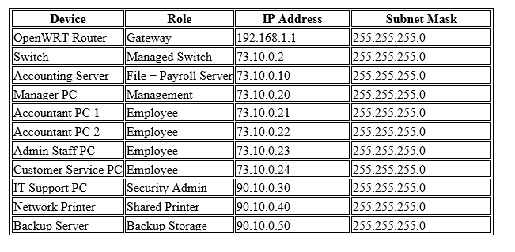

6. Security Hardening
The OpenWRT system was hardened to remove easy to exploit vulnerabilities and whatever was done to make it more secure. Hardening involves increasing the level of security within the systems configurations, authentication, and minimizing the attack surface.
The initial security enhancement was to change the default root password. Common default credentials are compromised and common targets. Their use is reduced by changing them for a robust password of numbers, lowercase and uppercase letters, and symbols.

How password is stored in Linux systems was discussed by looking the /etc/shadow. Instead of storing unobscured passwords, they were stored as encrypted hashes. By identifying the format to be 'observed' as in hash, it was concluded that the credentials are using SHA-512 hashing, providing additional protection against whether or not the file is compromised, credential recovery is difficult.
An SSH key-based authentication was enabled to make remote administration more secure. Instead of just using passwords, public and private SSH keys have been generated and used. SSH keys offer a higher level of security than passwords as it is much more difficult to guess or break than a regular password. The risk can also be minimized by wiping the ability to login with a password.
Lastly, unneeded services on OpenWRT were de-selected and turned off. The resources used by services that are not used add to potential vulnerabilities. The elimination or deactivation of them decreases the attack surface, plus increases overall system security. These hardening practices help to better secure the confidentiality, integrity and proper management of network infrastructure.

7. Traffic Analysis
To capture packets, and analyse the communication of devices, the analysis was done with network traffic analysis tool: tcpdump on OpenWRT as well as with Wireshark in the Windows hosts' systems. The traffic was analyzed in two separate traffic captures – HTTP traffic and SSH traffic. The aim of this analysis is to compare ways people communicate that are not secure in the network with ways that are secure.
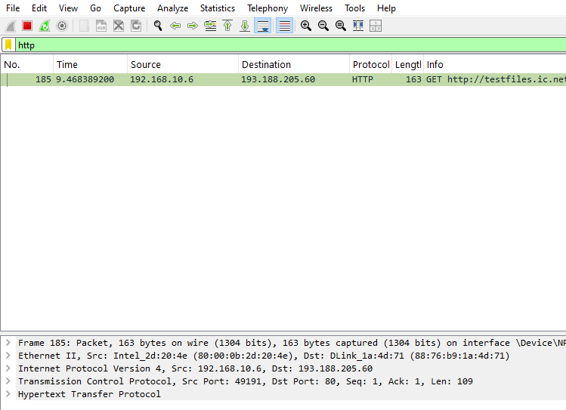

Packets captured at this point happened when attempting to access the business site via HTTP. When studying with Wireshark, it was found that data sent via HTTP was displayed unencrypted. The packet information consisted of IP addresses of the source and destination, requested URLs and fragments of the web content. Since information is not encrypted over the HTTP, sensitive information may be intercepted and could be read by the attackers that are network monitoring and/or man-in-the-middle.
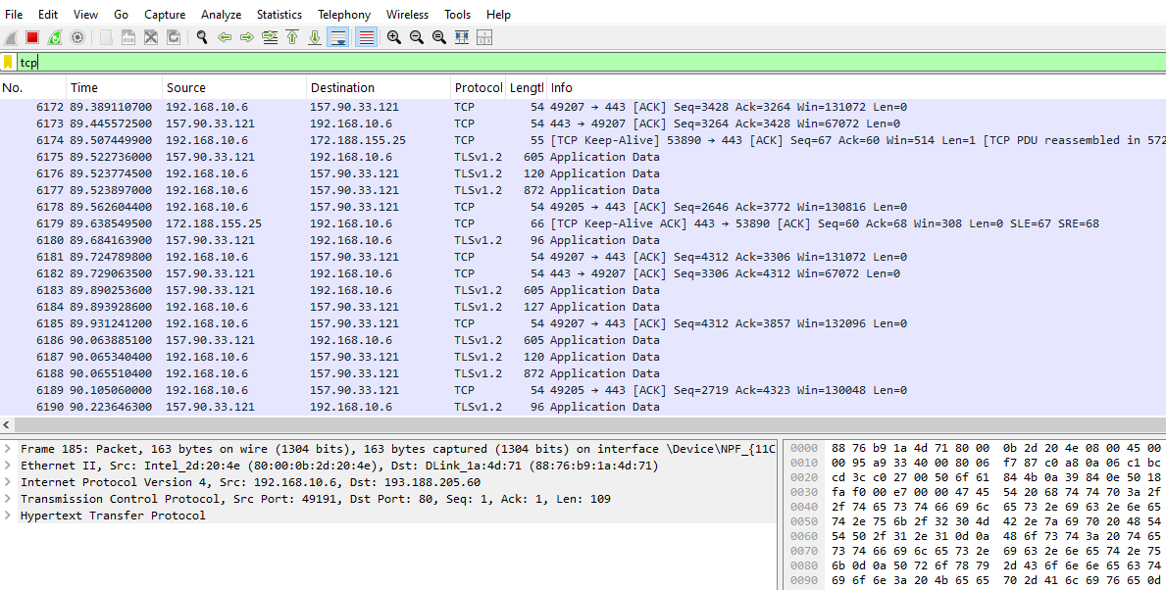

The second capture was a duplicate of a capture of the SS resulting from a remote login session to OpenWRT. Wireshark was able to reveal that the payload data for SSH packets was encrypted and thus, no readable data could be displayed. fark The source and destination addresses were still visible, but commands, passwords, and transmitted data had been very difficult to decipher. The comparison highlights the significance of encrypted protocols to ensure data confidentiality and avoiding knowledgeable disclosure in transit. Using secure protocols like SSH decreases the chances of information being stolen and/or intercepted by attackers, whereas insecure protocols like HTTP would release sensitive information to attackers.

8. Risk Assessment
To capture packets, and analyze the communication of devices, the analysis was done with network traffic analysis tool: tcpdump on OpenWRT as well as with Wireshark in the Windows hosts' systems. The traffic was analyzed in two separate traffic captures – HTTP traffic and SSH traffic. The aim of this analysis is to compare ways people communicate that are not secure in the network with ways that are secure.
Packets captured at this point happened when attempting to access the business site via HTTP. When studying with Wireshark, it was found that data sent via HTTP was displayed unencrypted. The packet information consisted of IP addresses of the source and destination, requested URLs and fragments of the web content. Since information is not encrypted over the HTTP, sensitive information may be intercepted and could be read by the attackers that are network monitoring and/or man-in-the-middle.
The second capture was a duplicate of a capture of the SS resulting from a remote login session to OpenWRT. Wireshark was able to reveal that the payload data for SSH packets was encrypted and thus, no readable data could be displayed. fark The source and destination addresses were still visible, but commands, passwords, and transmitted data had been very difficult to decipher.
The comparison highlights the significance of encrypted protocols to ensure data confidentiality and avoiding knowledgeable disclosure in transit. Using secure protocols like SSH decreases the chances of information being stolen and/or intercepted by attackers, whereas insecure protocols like HTTP would release sensitive information to attackers.

9. Security Controls
The client's financial records were determined to be the most critical data asset as they contain sensitive information about their customers, financial data, and confidential business records. A number of security controls are recommended to mitigate the risk and impact of cyber threats.

1. Multi-Factor Authentication (MFA)

All administrative accounts, remote systems and sensitive business applications should use Multi-Factor Authentication. MFA involves using two or more authentication factors to verify the user's identity, such as a password and a mobile verification code or a mobile authentication application. This control mitigates the risk of unauthorized access due to stolen or weak password. If credentials are breached via phishing or data breaches, attackers would still need the extra verification factor. An MFA drawback is that users might find themselves with a slight delay when logging in, and need assistance when setting up.

2. Regular Data Backups

Business-sensitive information ought to be backed up routinely, such as payroll records, client financial data, tax records, and staff data. Backups should be encrypted and kept out of the main disaster site, for example in secure cloud storage devices or offline systems. Frequent backups ensure that you can recover from ransomware attacks, accidental data loss and hardware failure, since data can be recovered easily. However, the backup solutions can cost more for storage and need regular testing to make sure that you'll be able to recover in case of an emergency.

3. Good Firewall Policy and Access Control

Firewall rules need to be continued to limit unnecessary traffic, block unused ports and limit access for administering purposes. Further controls like network segmentation and intrusion detection can enhance the security even further.

References:
[1] A. Gueye, C. Galhardo, I. Bojanova, and P. Mell, “A decade of reoccurring software weaknesses,” IEEE Security & Privacy, vol. 19, no. 6, pp. 74–82, 2021. doi: 10.1109/MSEC.2021.3082757.
[2] M. Alicea and I. Alsmadi, “Misconfiguration in firewalls and network access controls: Literature review,” Future Internet, vol. 13, no. 11, pp. 1–22, 2021. doi: 10.3390/fi13110283.
[3] G. Deshmukh, R. Kamble, and P. S. Solanki, “Protection of network devices and data security using firewall: A literature survey,” International Journal of Computer Sciences and Engineering, vol. 9, no. 11, pp. 39–44, 2021. doi: 10.26438/ijcse/v9i11.3944.
[4] M. I. Hussain, J. He, N. Zhu, Z. A. Zardari, F. Razque, S. Hussain, and M. S. Pathan, “An archetype for mitigating the security threats in multi-cloud environment by implementing tree-based next-generation firewalls,” Journal of Intelligent & Fuzzy Systems, vol. 41, no. 1, pp. 125–136, 2021. doi: 10.3233/JIFS-200835.
[5] V. S. Mai, R. La, and A. Battou, “Optimal cybersecurity investments in large networks using SIS model: Algorithm design,” IEEE/ACM Transactions on Networking, 2021. doi: 10.1109/TNET.2021.3091856.
[6] J. Haney, W. Lutters, and J. Jacobs, “Cybersecurity advocates: Force multipliers in security behavior change,” IEEE Security & Privacy, vol. 19, no. 4, pp. 54–59, 2021. doi: 10.1109/MSEC.2021.3077405.
[7] J. DeFranco, D. Ferraiolo, R. Kuhn, and J. Roberts, “A trusted federated system to share granular data among disparate database resources,” Computer (IEEE Computer), vol. 54, no. 3, pp. 55–62, 2021. doi: 10.1109/MC.2021.3049888.
[8] L. A. Meyer, S. Romero, G. Bertoli, T. Burt, A. Weinert, and J. L. Ferres, “How effective is multifactor authentication at deterring cyberattacks?,” 2023. [Online]. Available: arXiv:2305.00945.

